**Dal Baati**

***Introduction***

Dal Baati (दाल बाटी) is made up of two components: Dal and Baati. Dal is a soup made from lentil, and Baati roughly translates to hard wheat rolls. The dish is originally from Rajasthan, which is the desert of India. Rajasthan is also called the “Great Indian Desert”. It is located in the northern part of India. One does not usually expect a desert to be in the northern part of a country, but it is not very far from the Indian Himalayan Region. It is important to keep this in consideration when discussing this dish. A northern area mixed with a desert is brutal on the individuals who spend time working on farms or outdoors. The meals they eat, especially dal baati, help reflect their difficulties through the evolution of the food and the culture around it.

Dal Baati is not a very popular dish in India and is usually central to Rajasthan. It was really hard to research since it is not well documented. A lot of the people who consume dal baati do not have the means to document things online yet. To most Rajasthani people it is not a dish worth writing about since it is available in most places in Rajasthan, and is consumed in tons of parties and events that Rajasthani people go to[1]. Therefore, the recipes are usually verbally passed down generations, but not through writing. My grandmother does not think that it is something she will write down either, she feels like it is a dish that will definitely be passed down verbally since it is simplistic to make[2]. But, the downside is that her style of making the dish is lost. She makes dal baati very uniquely, and is one of the few people who use traditional methods to make this dish. In comparison to my mom, who makes it the more common and newer way. I will explain the method of making Daal Baati later on.

To gain more information on this dish I called a bunch of relatives in different parts of Rajasthan. A lot of the information presented below is going to be from real sources. Some of the historical information comes online sources, but they usually speculate on the history rather than pinpoint what actually happened. Therefore, I have not put a lot of weight on most of the online sources. The history that is presented in this document will be created by talking to farmers, soldiers, parents, grandparents, relatives, and chefs that I have personally called, and sources from the Internet. I wanted this piece to have a range of sources from successful chefs to farmers who used to work in areas my parents used to live in order to gain more perspective on the cultural evolution of the dish in Rajasthan.

Before starting to understand the historical background to this dish as a whole, let us explore what each of the components of this dish are, and their history:

***Baati***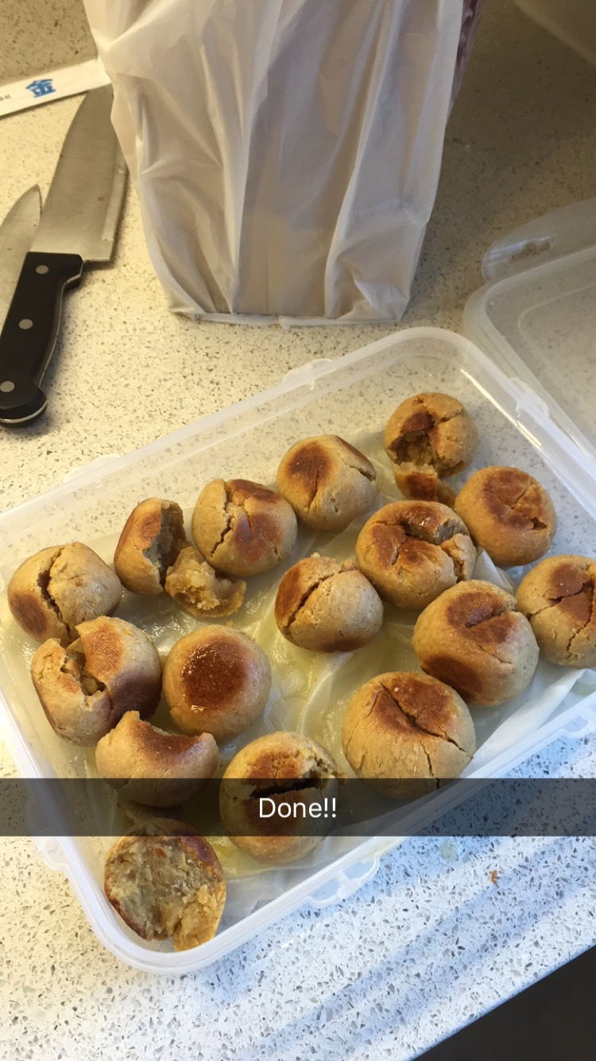

The image on the right is Baati (बाटी). The hard wheat rolls. It is ‘unleavened bread cooked’[3]. Basically, it is bread that is ‘made without yeast or other leavening agent’[4]. This means that the dough can be created with very simple ingredients, and the heat of the desert will do the rest. It does not need to be monitored by an individual, but can allowed to be prepared on its own. An advantage this dish has in the desert is that it uses a very tiny amount of water, which is usually scarce in Rajasthan. In addition, Baati can last a long time and is very nutritious if made with ghee (clarified butter) and/or with other fillings (such as peas, onions, or others).

Each of these characteristics show that Baati is very versatile. It can be prepared for a grand celebration or for survival. One can enjoy it in a dining hall as one enjoys bread at a restaurant, and one can enjoy it around a desert fire in the middle of Rajasthan[5]. This versatility is incredibly important in the evolution of the dish as we consider one question: why is dal baati very culturally significant? How did the dish evolve culturally and economically? What were the different types of people in the city who were responsible to eat this dish?

***Dal***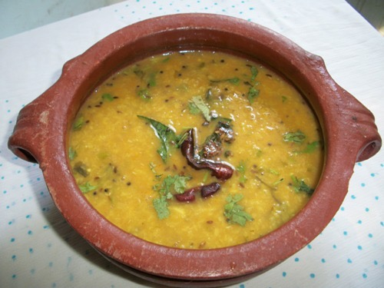

The image on the right is Dal (दाल). Dal is basically dried pulse. Pulse is a type of bean, for example, lentil, pea, etc. Dal is a staple food in India, and is very commonly eaten with chapati (or roti) as well. Dal is also a valuable source of proteins to the population that does not consume meat, and so the evolution of it as a staple was necessary to the vegetarian population. Having spoken to a lot of individuals who make dal baati, the dal part is equally valuable to the experience that one has eating this dish as it creates a balanced diet for those who do not consume meat. Without the balanced diet dal baati becomes very starchy, and is something that is not sustainable to eat.

Dal, similarly to baati, is very simple to make and is something that most households make on a daily basis. The basic ingredients of dal are the dal itself mixed in water with some turmeric, salt, and some kind of fried garnish. Dal also has different varieties which is valuable to note since it leads to a lot of variations depending on the culture of availability of specific types of ingredients[6]. In addition, another similarity that dal and baati have is that both of them require a very little amount of water to be made.

It is interesting to think about the history of lentils and how these beans became important in Indian history. Is it for nutrition or because of their availability? Or both? The lentil is native to West Africa, and has been eaten by people for over 60,000 years now. It was brought to Northern India sometime before 2,500 BC. It has developed into many different dishes in India since that time. Different regions of India utilize these lentils differently. In South India they make dosa with them, in Rajasthan they make chana dal, in Madhya Pradesh they make dal bafla, and there are many other examples of dal being used in Indian cuisine.

Culturally, it is not surprising that dal was used in dal baati as well. It was a staple that was used in a variety of dishes, and proved to pair well with different kinds of breads (roti, naan, etc.). In addition, there are a lot of ways to make dal. You can mix a lot of different things in with it, which means that individuals can make variations of the dish depending on the occasion. For example, during a festival Indian farmers would make dal differently to how they would if they were eating it casually.

***Background***

This dish is very personal to my family and me. We have been eating it for as far as we can remember, but when I talk about the history of the dish itself with them none of them know it. They only know the history of the dish up to their grandparents, and how they used to prepare it for them. But, they do not know anything about the dish outside of that. This trend continues among other families too as I got my close friends to ask their parents, and also generally asked around with other family friends.

In a sense, I want to introduce this dish to you in a way that highlights the experience my family and I have had in eating this dish. The personal experience of what this dish represents to us, why we make it in the way we do, and why we feel the connection of this dish to our history and the way we were brought up.

***How is it made?***

There are three methods of making baati. The first is an older method that is used less frequently now, the second is a newer method, which is used by restaurants and families in Rajasthan and around the world now, and the third method is one that catering companies in Rajasthan that use it to make a lot of baatis at once. To put this into context, the first method was learnt and used pre-1960s, the second made became more popular post-1960s as electric ovens became more popular, and the last method has been used for the last couple hundred years among catering families.

The process of making dal is well documented online. It requires a pressure cooker and dal. Since it is so widely available in every Indian store it is not very interesting to explore and look at the history of. One can learn the recipe [here](http://www.vegrecipesofindia.com/dal-tadka-recipe-homestyle/).

Here’s a basic demonstration on Youtube on how to make the balls of flour that become baati: [1](https://www.youtube.com/watch?v=FKWYHgJhFqc), [2](https://www.youtube.com/watch?v=U4xTwiUdfhE), [3](https://www.youtube.com/watch?v=OCSyNzTIgyk), and [4](https://www.youtube.com/watch?v=qkCRgGrxoGg) (created by my parents!). It is much easier to have a visual understanding of how to make baati. Verbally a baati is just flour, milk, and ghee created into a ball. Then you take this ball and you heat it for a period of time (depending on your method). The heat will harden the ball, and you’ll have a baati!

The first method is one I relate to strongly since my grandmother uses it frequently, and it is something that has been lost in history. There’s not much documentation on this method anymore, and it is something that is verbally passed down nowadays. You have to create the balls of flour using the ingredients as said above. You create a lot of these balls. You wrap each of the balls in some kind of plastic, and you put all of them in a rucksack. Then you dig a hole (about 1 metre in height) in your backyard (Rajasthan is a desert so the ground is usually very warm) and burry the rucksack inside. The first time I saw this happening I very quickly assumed they were burying someone, and was terrified. When the rucksack is filled it somewhat looks like a person. This process takes 2-3 days. You have to leave the rucksack under the ground to heat the balls of flour so they can turn into baati[7]! At night the baati cools since the desert air is cooler at night, and in the day the baati heats. This is a very traditional method, and we will discuss the story for this in the next section.

The second method of making baati is to create the balls of baati, and use the oven instead of the ground. You are basically doing the same thing as you would underneath the ground, but expediting the process. The oven takes approximately an hour or two in comparison to the days it takes using the first method. Here are links to tutorials: [1](https://www.youtube.com/watch?v=FmkwklK6O-Y), [2](https://www.youtube.com/watch?v=QSbXWIVTV8U), and [3](https://www.youtube.com/watch?v=uhtEA9-YIHQ).

Third method: You prepare the balls of flour then you put them on top of heated coal. This is extremely useful when preparing a lot of baatis as you can spread this across the desert floor, and leave your baatis to heat[8]. It works in the same way as the oven does, but you occasionally need to flip the baatis. [Here](https://www.youtube.com/watch?v=F4svROltuak) is a demonstration on Youtube on how one is able to do this. It is a very informative video since it shows off many different aspects of Rajasthani culture.

***Culture, variations, and ending questions***

Variations are important to understand: how did the culture in different parts of the state evolve with the food? There's a clear distinction that we can draw from because the dishes evolved depending on availability of resources, and need. Hotter and farm land places had different variations. Dal Baati is different in farm lands versus in cities. The filling that people put in the Baati differs a lot between people. So there's always a lot of new ways of experiencing the dish. It never gets old for me since many of my friends and family make it very differently. In some farm areas they usually fill the baati with peas or some kind of green vegetables. In some city areas they usually fill the baati with spicy foods. The interesting idea here is that every family and city has evolved the dish depending on their own take on it.

A lot of my memories each the dish have been eating it in variations. You can either make variations of the dal or you can make variations of the baati. Sometimes we eat plain baati with black dal or sometimes with yellow dal. It depends on the occasion that you’re in, which makes it fascinating. It also depends on family culture or values.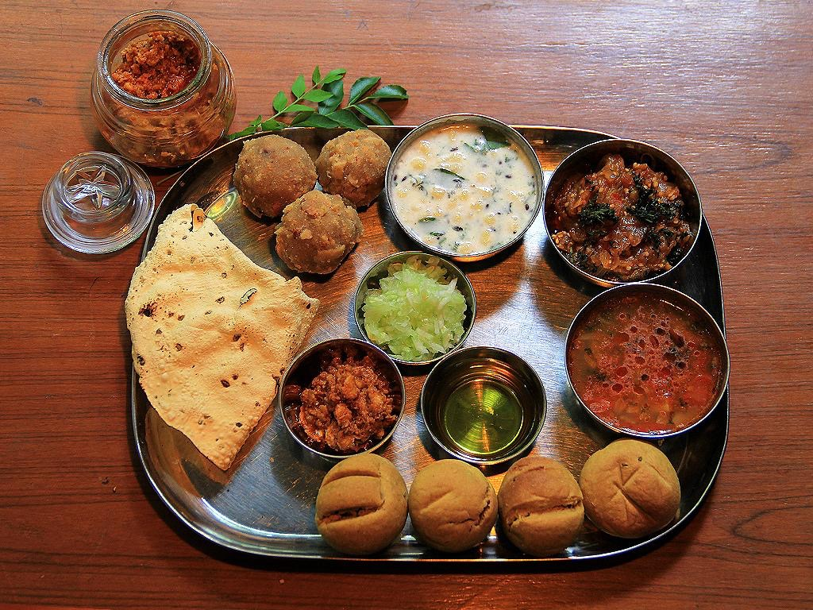

My favorite memory is eating it when I go to Newai, which is the town my mom’s parents live. My grandmother used to make it using the first method, which was putting the balls of flour into the rucksack and burying it under the ground. The dish on the right is a thali. This is a combination of daal, baati, and churma. These are three of the dishes that I believe to represent my culture and my city in Rajasthan, Jaipur. There are many dhaba restaurants where you can consume this particular dish.

From this discussion we can raise three questions:

1. Was this dish unaffected or affected by the British colonization of the dish?
2. There's a lack of these dishes in NYC. Why is that? Who governs what Indian dishes work and do not work in NYC?
3. Why was it initially made and what different cultures in India influence it? Who were the people who used to eat it in the past?

These three questions seem unanswered to me. I was not able to call or look up documentation on these issues. I talked to a bunch of restaurant owners in New York, and it seemed like they thought it was either not going to be popular or not known by people. I hope to arrive to these answers in the future.

1. Phone call with Indian Chef who lives in Newai, Tonk district, Rajasthan, India. He works on a dhaba (roadside restaurant). Paraphrasing and translating what he said in Hindi.
2. Phone call with grandmother. Paraphrasing and translating what she said in Hindi.
3. Reference: https://en.wikipedia.org/wiki/Baati
4. Reference: http://www.dictionary.com/browse/unleavened
5. Phone call with Indian Chef who lives in Jaipur, Rajasthan, India. He works on a ‘5-star restaurant’. Paraphrasing and translating what he said in Hindi.
6. Phone call with Indian Chef who lives in Udaipur, Rajasthan, India. He works on a dhaba (roadside restaurant). Paraphrasing and translating what he said in Hindi.
7. Phone call with grandfather. Paraphrasing and translating what she said in Hindi.
8. Phone call with Indian Chef who lives in Newai, Tonk district, Rajasthan, India. He owns a restaurants that does catering. Paraphrasing and translating what he said in Hindi.